

**Thomson Reuters –Log Backups Implementation Doc**

**Synopsis:** This document details the NetApp clustered Data ONTAP solution used for backups of log files from Oracle, SQL Server, and MySQL databases.

**Authors:** Santhana Ramasamy/Kevin Atkin

**Contributors:**

**Document Version:** V5

**Date:** August 2017

**CONFIDENTIAL INFORMATION**

This document contains information proprietary to Thomson Reuters and may not be reproduced, disclosed or used in whole or part without express permission of Thomson Reuters.

© Thomson Reuters 2017

Contents

1 Introduction 3

1.1 Management Summary 3

1.2 Assumptions 3

1.3 Change History 3

1.4 Distribution List 4

1.5 Glossary 4

2 Log file management 5

2.1 Log file retention and pruning 5

2.2 Oracle archive logs 5

2.3 SQL Server logs 5

2.4 MySQL logs 5

3 Clustered ONTAP provisioning CLI examples 6

3.1 Physical network configuration 6

3.1.1 Create a VLAN tagged interface group 6

3.1.2 Configure jumbo frames and disable flowcontrol 6

3.1.3 Configure failover groups 6

3.2 Aggregate creation 7

3.2.1 Create aggregate with free space reallocation enabled 7

3.3 Vserver and LIF creation 7

3.3.1 Create Vserver 7

3.3.2 Create LIF with default route and failover group 7

3.4 DNS configuration 8

3.4.1 Setup DNS on a Vserver 8

3.5 NFS and CIFS configuration 8

3.5.1 Enable NFSv3 8

3.5.2 Enable CIFS 8

3.5.3 Configure name mapping 8

3.6 Volume creation 8

3.6.1 Create volume and share for NFS access 8

3.6.2 Create volume and share for CIFS access 9

3.7 QoS configuration 11

3.7.1 Create and assign QoS policy group for workload tracking 11

3.8 Storage Efficiency configuration 11

3.8.1 Create job schedule and efficiency policy 11

3.8.2 Enable compression on a volume and assign efficiency policy 11

4 Pruning Script Example 11

4.1 Script schedule...................................................................................................................................................12

4.2 LIF migration .....................................................................................................................................................12

4.3 Volume move......................................................................................................................................................12

5 **Migrating from 7-mode to C-mode volume/share.................................................................................13**

5.1Oracle archive logs migration......................................................................................................................13

5.2 SQL Server logs Migration.............................................................................................................................14

5.3 Mysql logs Migration**....................................................................................................**14

5.4 Storage failover step by step method**.........................................................................**15

# Introduction

## Management Summary

This document details the NetApp clustered Data ONTAP solution used for backups of log files from Oracle, SQL Server, and MySQL instances. The storage system configuration of Vservers, Networking, Volumes, and Storage Efficiency will be covered in detail. The following drawing gives a high level overview of the solution.

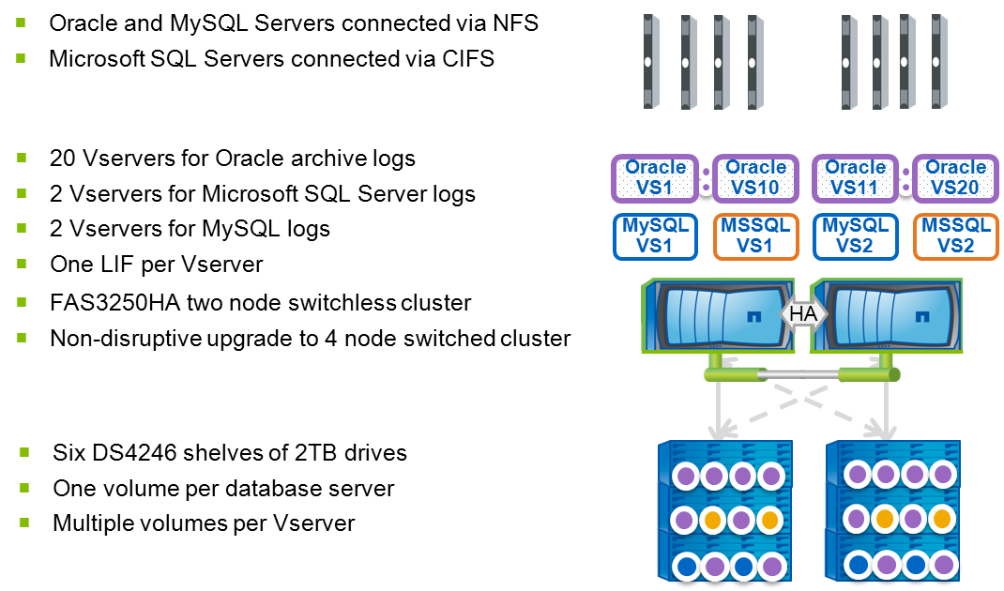

## Assumptions

It is assumed the person(s) reading this document are conversant with NetApp hardware and software. They will also be conversant with the Linux and Windows operating systems, NFS and CIFS protocols, and database systems at a high level.

## Change History

|  |  |  |  |
| --- | --- | --- | --- |
| **Ver** | **Date** | **Author** | **Key Changes** |
| 1 | 01-Jan-2013 | Santhana Ramasamy | Initial draft |
| 2 | 01-Jan-2013 | Santhana Ramasamy | Added examples and steps for all the provisioning. |
| 3 | 02-Jan-2013 | Santhana Ramasamy | Added Lif migrate,Vol move |
| 4 | 02-Jan-2013 | Santhana Ramasamy | Added command table |
| 5 | 08-August-2018 | Ian Daniel | Modified default export policy |

## 

## Distribution List

|  |  |
| --- | --- |
| **Name** | **Role** |
|  |  |
|  |  |
|  |  |
|  |  |
|  |  |

## Glossary

|  |  |
| --- | --- |
| **Term** | **Definition** |
| cDOT | clustered Data ONTAP |
| Vserver | A logical storage virtual server, also known as a Storage Virtual Machine (SVM), which contains LIFs, Volumes, and configuration information such as access control details. |
| LIF | Logical Interface – a cDOT logical network interface with an IP address, assigned to a single Vserver. |
| QoS | Quality of Service – introduced in cDOT 8.2 to provide workload monitoring and throughput rate limiting as desired. |
| WFA | OnCommand Workflow Automater – An automation framework application from NetApp, used for storage provisioning. |

**References**

**All the detailed information on this solution is available under Netapp deployment document from Mike Arndt NetApp clustered Data ONTAP solution used for backups of log files from Oracle, SQL Server, and MySQL databases.**

**2 Log file management**



## ****Log file retention and pruning****

**Log files will be kept online on the log backup environment for a period of time based on the retention setting as denoted in the volume name. A simple script will be run on a nightly basis from the NetApp OnCommand Unified Manager (DFM) servers in each module in order to remove log files older than two weeks. The *Pruning Script Example* section of this document shows a simple version of a script that would be run from cron on a DFM server to prune the log files.**

**In order for this script to prune logs from SQL Server logs, as wells as Oracle and MySQL logs, all log backups volumes must be exported to the DFM server for the module that will manage the log backup storage system. In addition, name-mapping must be configured on the SQL Server log backup Vservers in order to map the root account from unix to a local administrator account on the Vserver. This name-mapping will allow the root account on the DFM server that is doing the log pruning to have full privileges to the NTFS security style volume.**

## ****Oracle archive logs****

**Oracle servers in the environment will be configured with a primary and alternate archive log destination. The primary archive log destination will be the cDOT based log backup environment as described in this document, and will hold all archive logs on a regular basis. A secondary, and much smaller, archive log destination will be configured on a standard NetApp low tier shared storage system as a method of redundancy. This location will initially be a 7 Mode NetApp storage system, but may switch to another cDOT NetApp low tier storage system over time.**

## ****SQL Server logs****

In the SQL Server environment, log backups are managed by SQL Agent jobs created by the SQL DBA. SQL Server full backups are performed by NetApp SnapManager for SQL (SMSQL), but SMSQL does not perform any log management. All SQL Server log backups and restores are performed by the SQL Server DBA, using the CIFS share provided for each SQL Server by the log backup solution described in this document. **A secondary, and much smaller, SQL Server log destination will be configured on a standard NetApp low tier shared storage system as a method of redundancy. This location will initially be a 7 Mode NetApp storage system, but may switch to another cDOT NetApp low tier storage system over time.**

## MySQL logs

MySQL logs will be copied to the log backup environment via a simple NFS mountpoint on the MySQL server.

# Clustered ONTAP provisioning CLI examples

While WFA is meant to be used for all storage provisioning in the log backup environment, it may be useful to know the exact commands that would be used in the event that provisioning needed to be done manually for any reason.

## ****Physical network configuration****

### Create a VLAN tagged interface group

network port ifgrp create -node <node> -ifgrp a0a -mode multimode_lacp -distr_func ip

network port ifgrp add-port -node <node> -ifgrp a0a -port <port>

network port ifgrp add-port -node <node> -ifgrp a0a -port <port>

network port vlan create -node <node> -port a0a -vlan-id <vlan>

network port ifgrp show

network port vlan show

network port show

### Configure jumbo frames and disable flowcontrol

network port modify -node <node> -port a0a -mtu 9000

network port modify -node <node> -port <port> -flowcontrol-admin none

network port modify -node <node> -port <port> -flowcontrol-admin none

network port show

network port show –instance

### Configure failover groups

network interface failover-groups create -failover-group <groupname> -node <node1> -port a0a-<vlan>

network interface failover-groups create -failover-group <groupname> -node <node2> -port a0a-<vlan>

network interface failover-groups show

network interface show –failover

## ****Aggregate creation****

### Create aggregate with free space reallocation enabled

storage aggregate create -aggregate aggr1_<node> -nodes <node> -diskcount <diskcount> -raidtype raid_dp -maxraidsize <raidsize>

storage aggregate modify -aggregate aggr1_<node> -free-space-realloc on

storage disk show

storage aggregate show

storage aggregate show -instance

## ****Vserver and LIF creation****

### Create Vserver

vserver create -vserver <vsname> -rootvolume <vsname>_root-aggregate <aggrname> -ns-switch file -nm-switch file -rootvolume-security-style unix -language C.UTF-8

vserver show

Example,

**lab3250::vserver> vserver create -vserver eag-wfa-cifs-01 -rootvolume eag_wfa_cifs_01 -aggregate aggr1_lab3250_01 -ns-switch file -nm-switch file -rootvolume-security-style unix -language C.UTF-8**

### Create LIF with default route and failover group

network interface create -vserver <vsname> -lif <vsname>_lif1 -role data -data-protocol nfs,cifs -home-node <node> -home-port <port> -address <ip> -netmask <netmask> -status-admin up -firewall-policy mgmt -failover-group <group>

network routing-groups route create -vserver <vsname> -routing-group d<network>/<mask> -destination 0.0.0.0/0 -gateway <gateway>

vserver show

network interface show

network interface show -failover

network routing-groups route show

**Example,**

**lab3250::vserver> network interface create -vserver eag-wfa-cifs-01 -lif eag-wfa-cifs-01_lif1 -role data -data-protocol cifs -home-node lab3250-01 -home-port a0a-2003 -address 10.220.130.169 -netmask 255.255.254.0 -status-admin up -firewall-policy mgmt -failover-group data-2003**

## ****DNS configuration****

### Setup DNS on a Vserver

vserver services dns create -vserver <vsname> -domains <domainname> -name-servers <comma_separate_name_server_list>

vserver services dns show

**Example,**

**lab3250::vserver> vserver services dns create -vserver eag-wfa-cifs-01 -domains tlr.thomson.com -name-servers 163.231.22.50,163.231.22.34**

## ****NFS and CIFS configuration****

### Enable NFSv3

vserver nfs create -vserver <vsname> -access true -v3 enabled

vserver nfs show

### Enable CIFS

cifs create -cifs-server <vsname> -domain <ad_domain> -ou CN=Computers -status-admin up -vserver <vsname>

cifs show

cifs options show

**Example,**

**lab3250::vserver> cifs create -cifs-server eag-wfa-cifs-02 -domain tlr.thomson.com -ou "OU=Managed Servers" -status-admin up -vserver eag-wfa-cifs-01**

### Configure name mapping

vserver name-mapping create -vserver <vsname> -direction unix-win -position 1 -pattern root -replacement <vsname>\\administrator

vserver name-mapping show

diag secd name-mapping show -node <node> -vserver <vserver> -direction unix-win -name root

## ****Volume creation****

### Create volume and share for NFS access

**Note:** Default export policy is read only.

vserver export-policy create -vserver <vsname> -policyname <policyname>

vserver export-policy rule create -vserver <vsname> -policyname default -clientmatch <nfsclients> -rorule sys -rwrule never -superuser none

vserver export-policy rule create -vserver <vsname> -policyname <policyname> -clientmatch <nfsclients> -rorule sys -rwrule sys -superuser sys

volume create -vserver <vsname> -volume <volname>_nosnap -aggregate <aggrname> -size <size> -policy <policyname> -snapshot-policy none -junction-path /<volname> -security-style unix –space-guarantee none –percent-snapshot-space 0 –language C.UTF-8

volume show

vserver export-policy rule show

Example,

**Policy creation:**

**lab3250::> vserver export-policy create -vserver lab-arch-001 -policyname orfcmode_mysqllabtest3d_n01arch1_7_nosnap**

**Rule creation:**

**lab3250::> vserver export-policy rule create -vserver lab-arch-001 -policyname orfcmode_mysqllabtest3d_n01arch1_7_nosnap -clientmatch orf-mysql-3.int.thomsonreuters.com -rorule sys -rwrule sys -protocol nfs3 -superuser sys**

**Vol creation:**

**lab3250::> vol create -vserver lab-arch-001 -volume orfcmode_mysqllabtest3d_n01arch1_7_nosnap -aggregate aggr1_lab3250_01 -size 100G -policy orfcmode_mysqllabtest3d_n01arch1_7_nosnap -snapshot-policy none -junction-path /orfcmode_mysqllabtest3d_n01arch1_7_nosnap -security-style unix -space-guarantee none -percent-snapshot-space 0 -language C.UTF-8**

**(volume create)**

**[Job 1660] Job succeeded: Successful**

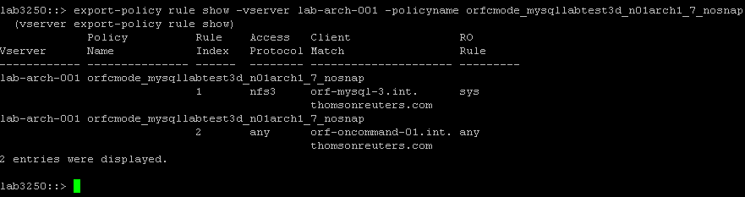

### Create volume and share for CIFS access

volume create -vserver <vsname> -volume <volname>_nosnap -aggregate <aggrname> -size <size> -snapshot-policy none -junction-path /<volname> -security-style ntfs –space-guarantee none –percent-snapshot-space 0 –language C.UTF-8

cifs share create -vserver <vsname> -share-name <volname> -path /<volname>

cifs share access-control create -share <volname> -user-or-group <usergroup> -permission Full_Control

volume show

cifs share show

cifs share access-control show

**Example:**

**lab3250::vserver> vserver create -vserver eag-wfa-cifs-01 -rootvolume eag_wfa_cifs_01 -aggregate aggr1_lab3250_01 -ns-switch file -nm-switch file -rootvolume-security-style unix -language C.UTF-8**

**lab3250::> cifs share access-control create -share logarch_test14 –**

**user-or-group administrator -permission Full_Control**

**Listing the share permissions:**

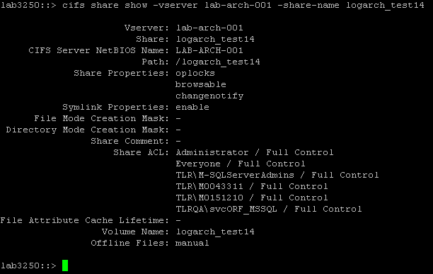

**Modifying the permission:**

**lab3250::> cifs share access-control modify -share logarch_test14 –**

**user-or-group Administrator -permission Full_Control**

**Deleting the share:**

**lab3250::> cifs share access-control delete -share logarch_test14 -user-or-group Administrator -vserver lab-arch-001**

## ****QoS configuration****

### Create and assign QoS policy group for workload tracking

qos policy-group create -policy-group <volname> -vserver <vsname>

volume modify -vserver <vsname> -volume <volname> -qos-policy-group <volname>

qos policy-group show

volume show -instance

## ****Storage Efficiency configuration****

### Create job schedule and efficiency policy

job schedule cron create -name <schedule> -minute <min> -hour <hour>

volume efficiency policy create -vserver <vsname> -policy <policyname> -schedule <schedule> -qos-policy background

job schedule cron show

volume efficiency policy show

### Enable compression on a volume and assign efficiency policy

volume efficiency modify -vserver <vsname> -volume <volname> -compression true -inline-compression false

volume efficiency modify -vserver <vsname> -volume <volname> -policy <policyname>

volume efficiency show –instance

df –h –S

**4 Pruning Script Example**

The following shell script shows a simple example of how to perform the pruning of log backups from a DFM server. The following assumptions are made by the script:

1. The LOGBASEDIR variable is the base directory on the DFM server where all log backup volumes get mounted.
2. The log backup volumes are mounted in subdirectories of the LOGBASEDIR directory, with the subdirectory name matching the volume name.
3. The script is run nightly from cron, as the root user.

#!/bin/bash

LOGBASEDIR="logbasedir"

find $LOGBASEDIR -path '*_7_*' -type f -mtime +7 -exec rm {} \;

find $LOGBASEDIR -path '*_14_*' -type f -mtime +14 -exec rm {} \;

find $LOGBASEDIR -path '*_45_*' -type f -mtime +45 -exec rm {} \;

## Script schedule:

This script will run on every day midnight and it will check for the file retentions to delete the files as per the retention set. It basically looks for the specific directories and will clear the old files accordingly.

**Complete command sets for CIFS and ISCSI**

Below table shows the list of commands and the steps for completing the following,

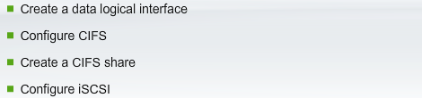

|  |  |  |
| --- | --- | --- |
|  | **Step List** | **Commands** |
| 1 | List network interfaces | Network interface show |
| 2 | List network interfaces for vserver ORUSR | Network interface show -vserver ORUSR |
| 3 | List network routing groups | network routing-groups show |
| 4 | List network routing groups for vserver ORUSR | network routing-groups show -vserver ORUSR |
| 5 | Create a network routing group route for vserver ORUSR using routing group d10.254.132.0/22 destination 0.0.0.0 and GW 10.254.132.1 | network routing-groups route create -vserver ORUSR -routing-group d10.254.132.0/22 -destination 0.0.0.0/0 -gateway 10.254.132.1 |
| 6 | verify that we can communicate with nau01.TR.com | ping -lif-owner ORUSR -lif data1 -destination nau01.netappu.com |
| 7 | List the DNS servers that are defined for each node in the cluster. | system services dns show |
| 8 | List the vservers in the cluster | vserver show |
| 9 | List the Name service switch for Vserver ORUSR | vserver show -vserver ORUSR |
| 10 | List the unix users defined in the cluster | vserver services unix-user show |
| 11 | Create a unix user named root for Vserver ORUSR | vserver services unix-user create -vserver ORUSR -user root -id 0 -primary-gid 0 |
| 12 | List the unix users defined for the cluster | vserver services unix-user show |
| 13 | List the NIS domains defined for the cluster | vserver services nis-domain show |
| 14 | Create a Nis domain named gx.NetappU.com with server 216.240.23.30 for vserver ORUSR | vserver services nis-domain create -vserver ORUSR -domain gx.netappU.com -active true -servers 216.240.23.30 |
| 15 | List the Nis domains defined for the cluster one more time | vserver services nis-domain show |
| 16 | Change the name service switch for vserver ORUSR to nis,file | vserver modify -vserver ORUSR -nas-switch nis,file |
| 17 | List the name service switch for vserver ORUSR | vserver show -vserver ORUSR |
| 18 | List the name mappings | vserver name-mapping show |
| 19 | Create a windows to unix name mapping for vserver ORUSR | vserver name-mapping create -vserver ORUSR -direction win-unix -position 1 -pattern (.+) -replacement root |
| 20 | Create a unix windows name mapping for vserver ORUSR | vserver name-mapping create -vserver ORUSR -direction unix-win -position 1 -pattern (.+) -replacement NAU01\\\1 |
| 21 | List the name mappings again fror verification | vserver name-mapping show |
| 22 | List the CIFS servers defined for the cluster | vserver cifs show |
| 23 | Create an active directory machine account for the CIFS server | vserver cifs create -vserver ORUSR -cifs-server NODE01 -domain nau01.netappu.com |
| 24 | Now list the CIFS shares | vserver cifs share show |
| 25 | Create a CIFS share named root that maps to the root(/) of virtual ORUSR | vserver cifs share create -share-name root -path / |
| 26 | Show the CIFS share. | vserver cifs share show |

## Lif migration:

List the current configuration for **LIF: eag_wfa_cifs_03_lif**

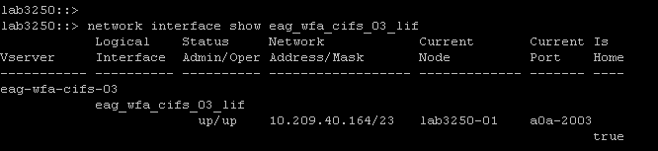

Migrating to different node,

**Command:** network interface migrate -vserver eag-wfa-cifs-03 -lif eag_wfa_cifs_03_lif -dest-node lab3250-02 -dest-port a0a-2003



Status after the migration,

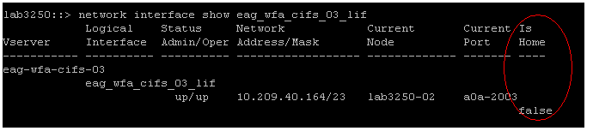

This can be confirmed by looking at the ‘IS HOME’ on the right hand side. This confirms the LIF is migrated successfully.

**4.3 Volume move**

storage aggregate show

volume show

volume move -vserver ORUSR -volume root_ORUSR -destination-aggregate aggr5 -foreground true

Using the above command, volume: ORUSR is moved from the current aggr1 to aggr5.

**5 Migrating from 7-mode to C-mode volume/share**

## ****Oracle archive logs migration****

**Need to add the steps**

## ****SQL Server logs Migration****

Need to add the steps

## ****Mysql logs Migration****

Need to add the steps

## ****Storage failover step by step method****

During storage failover scenario all the LIF(Logical interfaces ) will failover to the partner and no service impact is expected during this failover. This is completely non-disruptive method. This method will be mainly used during Ontap upgrades or during any hardware replacement to avoid outages.

**# Disable storage auto giveback if required. (Standard is to disable this option by default)**

storage failover show -fields auto-giveback

storage failover modify -node nest-01 -auto-giveback false

storage failover modify -node nest-02 -auto-giveback false

**# Perform takeover in one direction**

network interface migrate-all -node nest-01

network interface show

storage failover takeover -bynode nest-02

storage failover show

<wait for 8 minutes>

**# Perform giveback of root aggregate**

storage failover giveback –from node nest-02 -only-cfo-aggregates

**# If you want, check that the 10Gb network is up on the node that just booted**

network ping -lif-owner nest-01 -lif nest_01_icl_lif -destination nerstrand.int.westgroup.net

**# Perform giveback of all other aggregates**

storage failover giveback –from node nest-02

**# If you need to override a giveback veto, do this**

storage failover giveback –from node nest-02 -override-vetoes true

**# Check status of system**

system node image show

storage failover show-giveback

storage aggregate show

**# Revert LIFs back to home node.**

network interface revert *

network interface show

**# Perform takeover in the other direction**

network interface migrate-all -node nest-02

network interface show

storage failover takeover -bynode nest-01 -option allow-version-mismatch

storage failover show

<wait for 8 minutes>

**# Perform giveback of root aggregate**

storage failover giveback –from node nest-01 -only-cfo-aggregates

**# If you want, check that the 10Gb network is up on the node that just booted**

network ping -lif-owner nest-02 -lif nest_02_icl_lif -destination nerstrand.int.westgroup.net

**# Perform giveback of all other aggregates**

storage failover giveback -fromnode nest-01

storage failover show-giveback

storage aggregate show

storage aggregate show -fields is-home

**# Revert LIFs back to home node**

network interface revert *

network interface show

system node image show

**# Re-enable storage auto giveback if required**.

storage failover modify -node nest-01 -auto-giveback true

storage failover modify -node nest-02 -auto-giveback true

storage failover show -fields auto-giveback